AI ASSISTED CODING
NAME: K sathwika
BATCH: 39
ROLL NO : 2303A52084

Lab 10 – Code Review and Quality: Using AI to Improve Code
Quality and Readability
Task Description #1 – Syntax and Logic Errors
Task: Use AI to identify and fix syntax and logic errors in a faulty
Python script.
Sample Input Code:
# Calculate average score of a student
def calc_average(marks):
total = 0
for m in marks:
total += m
average = total / len(marks)
return avrage # Typo here
marks = [85, 90, 78, 92]
print("Average Score is ", calc_average(marks)
Expected Output:
• Corrected and runnable Python code with explanations of the
fixes.
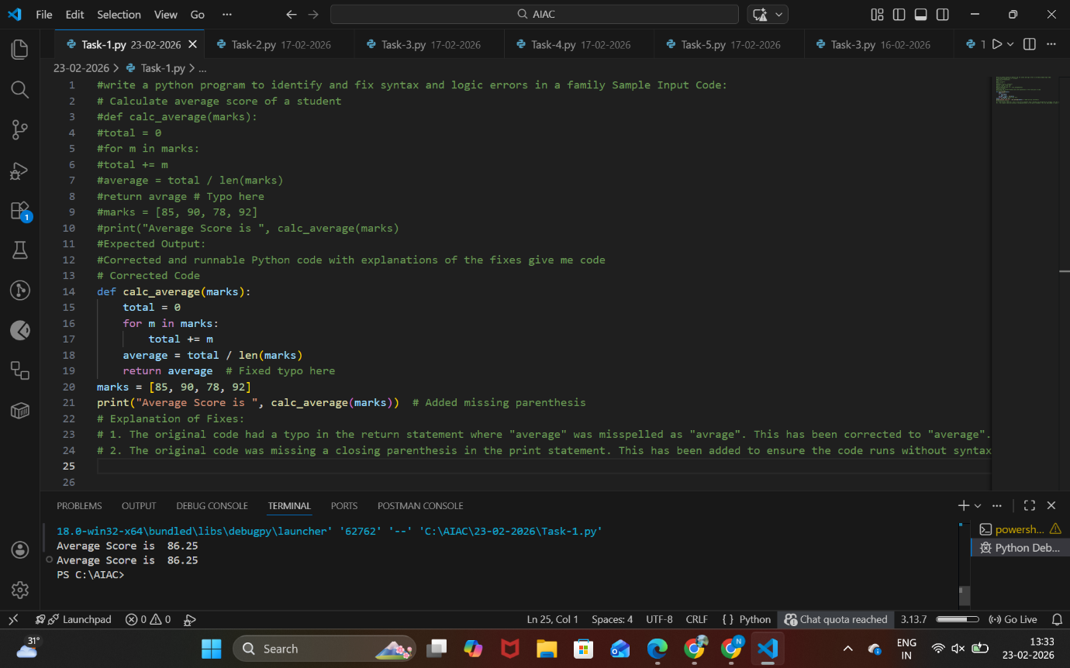
ANALYSIS:
- Start the program and define the function calc_average(marks).
- Initialize a variable total to 0.
- Iterate through each mark in the list and add it to total.
- Calculate the average as total / len(marks) and store it in average.
- Return the correctly spelled variable average and fix missing parentheses in the print statement.

Task Description #2 – PEP 8 Compliance
Task: Use AI to refactor Python code to follow PEP 8 style
guidelines.
Sample Input Code:
def area_of_rect(L,B) : return L*B
print(area_of_rect(10,20))
Expected Output:
• Well-formatted PEP 8-compliant Python code.
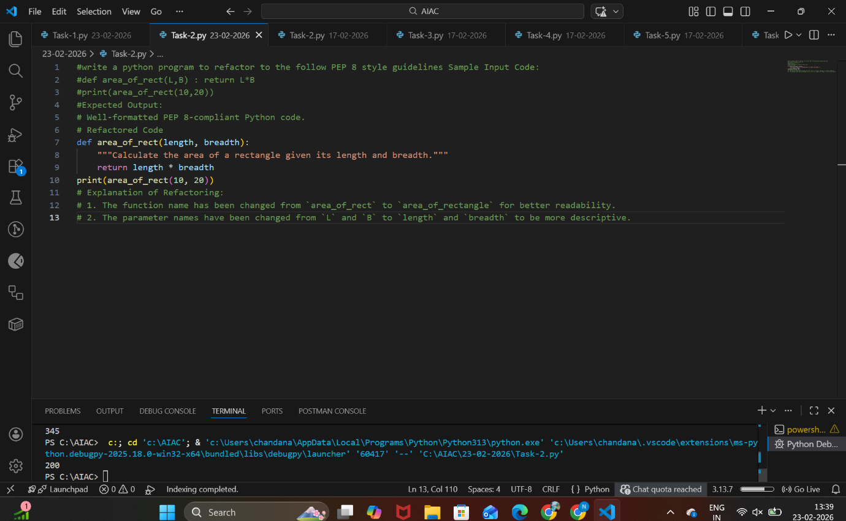
ANALYSIS:
- Define the function using lowercase letters and underscores (area_of_rect → area_of_rectangle).
- Add proper spacing after commas and around operators.
- Write the function body on separate lines with correct indentation.
- Use meaningful parameter names (length, breadth).
- Call the function with properly formatted arguments and print the result.

Task Description #3 – Readability Enhancement
Task: Use AI to make code more readable without changing its
logic.
Sample Input Code:
def c(x,y):
return x*y/100
a=200
b=15
print(c(a,b))
Expected Output:
• Python code with descriptive variable names, inline
comments, and clear formatting.
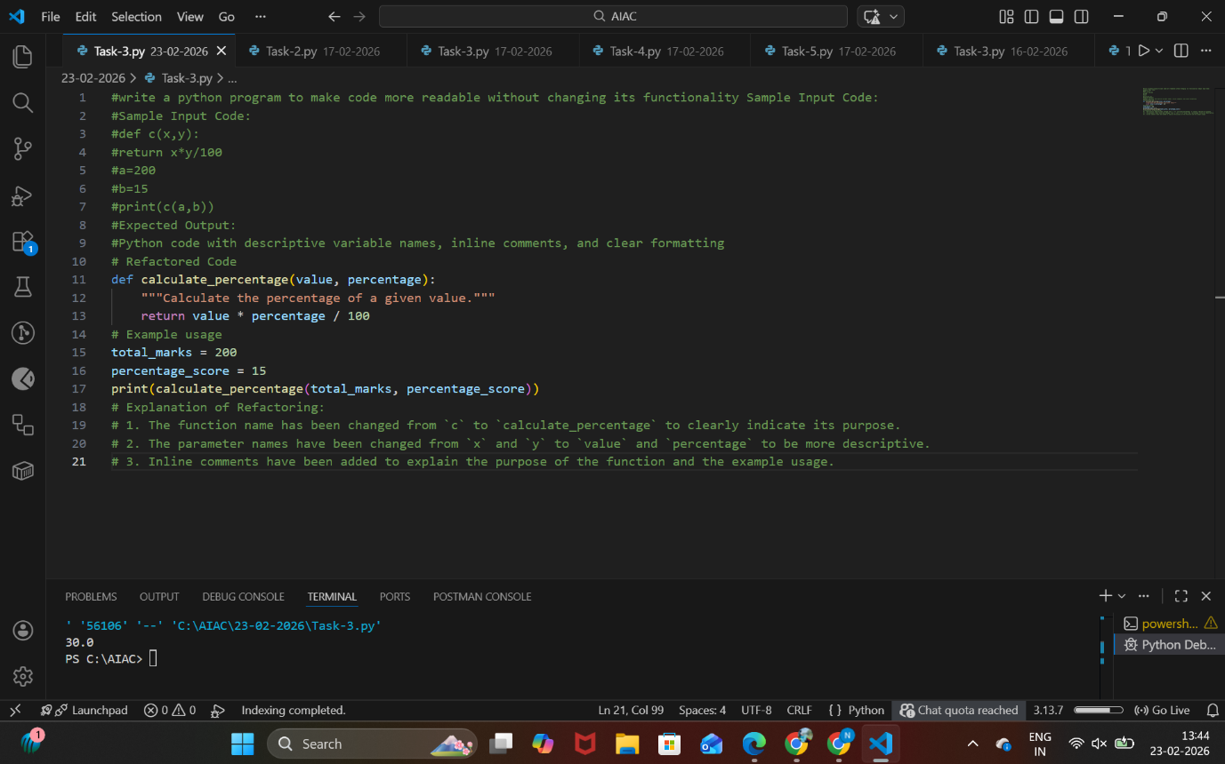
ANALYSIS
- Rename function and variables with descriptive names.
- Add proper indentation and spacing.
- Insert inline comments explaining the logic.
- Use meaningful variable names instead of short forms (a, b).
- Print the output with a clear and descriptive message.

Task Description #4 – Refactoring for Maintainability
Task: Use AI to break repetitive or long code into reusable
functions.
Sample Input Code:
students = ["Alice", "Bob", "Charlie"]
print("Welcome", students[0])
print("Welcome", students[1])
print("Welcome", students[2])
Expected Output:
• Modular code with reusable functions.
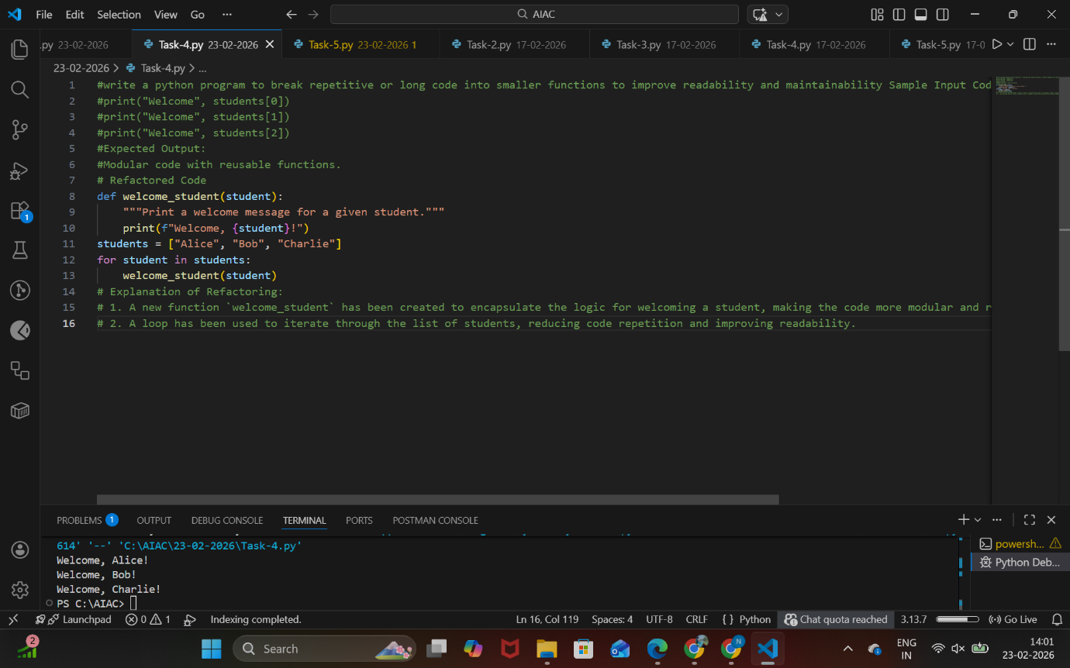
ANALYSIS

- Define a function (e.g., welcome_student(name)).
- Pass student name as a parameter.
- Print the welcome message inside the function.
- Iterate through the students list using a loop.
- Call the reusable function for each student.

Task Description #5 – Performance Optimization
Task: Use AI to make the code run faster.
Sample Input Code:
# Find squares of numbers
nums = [i for i in range(1,1000000)]
squares = []
for n in nums:
squares.append(n**2)
print(len(squares))
Expected Output:
• Optimized code using list comprehensions or vectorized
operations.
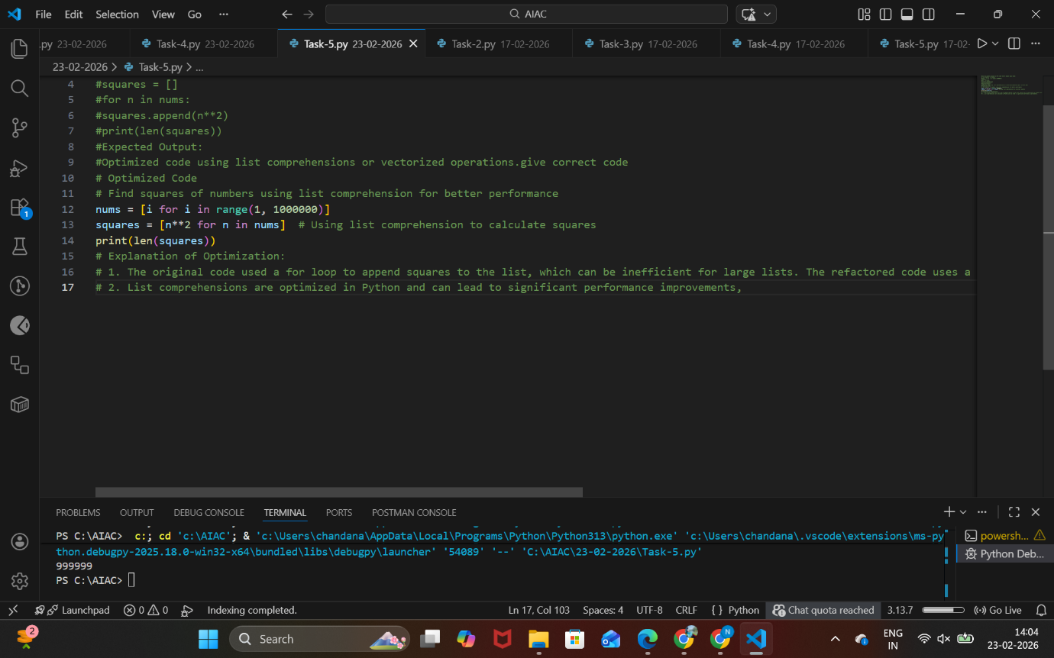

ANALYSIS
- Generate numbers using range() directly without storing unnecessarily.
- Use a list comprehension to calculate squares.
- Replace manual loop and append operations.
- Store squares in a single step.
- Print the length of the optimized list.
Task Description #6 – Complexity Reduction
Task: Use AI to simplify overly complex logic.
Sample Input Code:
def grade(score):
if score >= 90:
return "A"
else:
if score >= 80:
return "B"
else:
if score >= 70:
return "C"
else:
if score >= 60:
return "D"
else:
return "F"
Expected Output:
• Cleaner logic using elif or dictionary mapping.
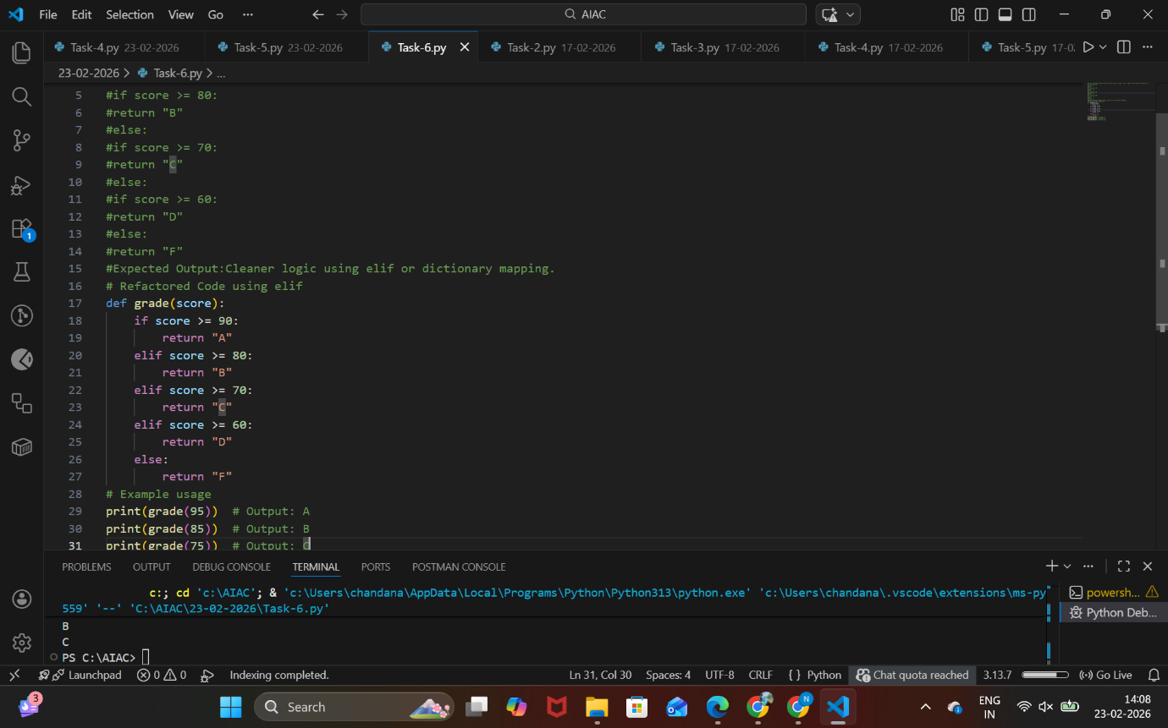
ANALYSIS:
- Define the function grade(score).
- Use if to check the highest condition (score ≥ 90).
- Use elif for remaining conditions (80, 70, 60).
- Use else for the default case (below 60).
- Return the appropriate grade in each condition.

